**Create a School Database**

**DESCRIPTION**

Using SQL Server MMC, create tables and indexes for storing students, subjects and classes data

**Background of the problem statement:**

Rainbow School is creating software for school management. The first stage is to design a database in SQL Server which will manage all the data. This database will then be used in the web-based application for school management.

**Tables:**

The following master tables will be created:

Student – store all student data across multiple classes

Subjects – master list of subjects taught in all classes

Classes – list of classes in the school

**GITHUB LINK:**

**https://github.com/DurgeshSingh01/Simplilearn_Practice_Project/tree/master/Phase_3_Projects**

SQL Queries:

Create database Rainbow_School

use Rainbow_School

go

create table Class

(

ClassID int primary key,

ClassName varchar(5)

)

create table Students

(

StudentID int Primary key not null,

StudentName varchar(20),

ClassID int foreign key references Class(classid)

)

create table Subjects

(

SubjectID int primary key,

SubjectName varchar(50),

ClassID int foreign key references Class(ClassID)

)

insert into Class values(1,'12A'),(2,'12B'),(3,'12C'),(4,'12D')

insert into Students values(11,'Deepansh',1),(12,'Archit',2),(13,'Chandra',3),(14,'Harshit',4),(15,'Atar',3),(16,'Daksha',1)

insert into Subjects values(1,'Maths',1),(2,'Chemistry',2),(3,'Physics',2),(4,'Economics',4),(5,'Accounts',4)

select * from Class

select * from Students

select * from Subjects

**CODE SNIPPET:**

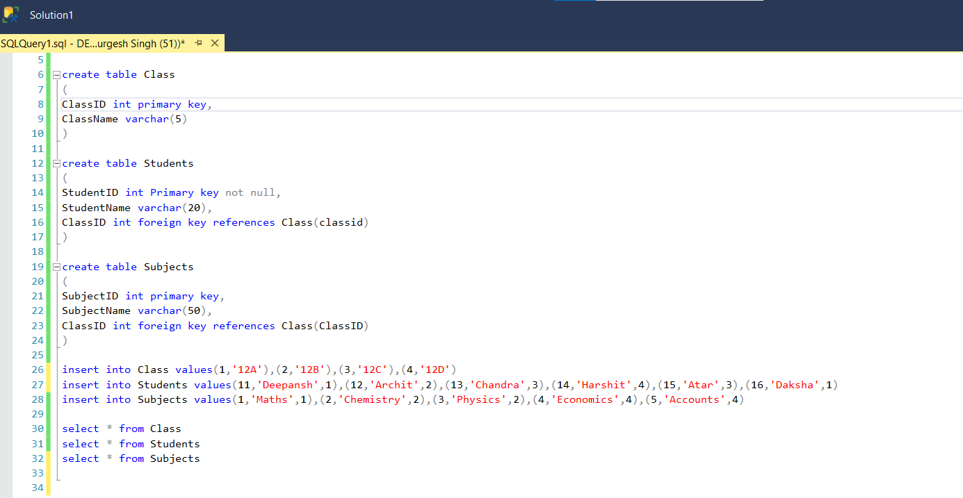

Output Snippet:

